Contributor: June Black

**Alvarez Bravo, Lola**

Born: 3 April 1903—Lagos de Moreno, Mexico; Died: 31 July 1993—

Born to a wealthy family in Jalisco, Dolores Martínez de Anda (always known as Lola) was brought up in luxury during her infancy and childhood. As a young woman, she lived through the upheaval of the Mexican Revolution, and in 1925 she married Manuel Alvarez Bravo, who had been a student of photography under Hugo Brehme. Early in their marriage, the Alvarez Bravos moved to Oaxaca where Lola began to learn about photography from Manuel. During their time in Oaxaca, the couple shared a camera and a dark room and worked in a similar style. Although Lola received less acknowledgement than Manuel during her lifetime, she is now recognised as an influential Mexican photographer and is often cited as the first Mexican-born woman to dedicate herself to the medium. During the early years of her career, Lola’s photographic aesthetic was strongly influenced by her husband, as well as Tina Modottiand Edward Weston (who worked in Mexico in the mid-‘20s) and Henri Cartier-Bresson andPaul Strand (who worked there in the mid-‘30s). Her later photomontages engaged with both Constructivism and Surrealism. In addition to being a photographer, she was a curator, educator, photojournalist, and general advocate for the arts in Mexico.

In 1934, Lola and Manuel separated, at which point Lola and her young son moved in with the painter María Izquierdo. No longer under the shadow of her husband, Lolabegan pursuing photography full time. Izquierdo’s home was a meeting place for artists, writers, intellectuals, and students, including Rufino Tamayo, Luis Cardoza y Aragón, Xavier Villaurrutia, Leopoldo Méndez, and David Alfaro Siqueiros. Lola and Izquierdo were both members of the radical artist’s group LEAR (*Liga de Escritores y Artistas Revolucionarios*—League of Revolutionary Artists and Writers) from its creation in 1934. Through her association with the organization, which modeled itself on the ideals of the Popular Front, she and Manuel worked with fellow artist Emilio Amero to create a film society that introduced the works of Luis Buñuel, Sergei Eisenstein, Vsevolod Pudovkin, and Dziga Vertov to Mexican audiences.

Lola’s populist aesthetic and interest in politics eventually led her to photojournalism. She was appointed chief photographer of the magazine *El Maestro Rural*, one of several socialist education projects developed in the thirties by the Ministry of Education. In addition to her photographs, her first photomontages were published in the magazine. She also worked as a photojournalist for *Vea*, *Voz*, *Avance*, *Futuro*, and *Espacio* and was the only female photographer following government ministers on their official tours at the time.

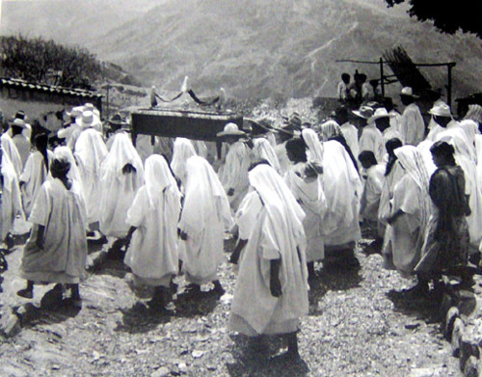

**Entierro en Yalalag (Burial in Yalalga)**

**1946**

© Center for Creative Photography, The University of Arizona Foundation

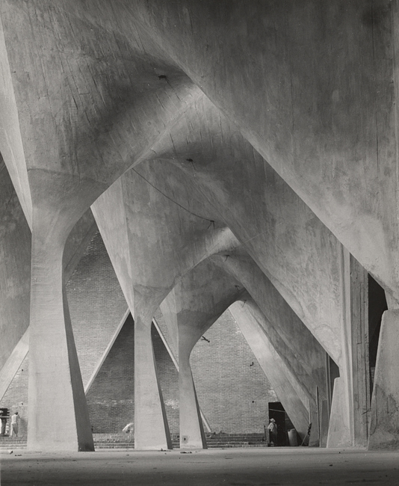

***Untitled* from 1954 from the Center for Creative Photography:**

During the 1930s, Lola became the chosen photographer of the Mexican muralists. Her success with them led her to direct the photographic workshop at the National Institute of Fine Arts, where she curated traveling exhibitions circulated to provincial cities in an attempt to decentralize culture in Mexico. Her experience curating motivated her to open her own gallery—the Galería de Arte Contemporáneo or GAC—in Mexico City in 1951. There Lola represented such artists as David Alfaro Siqueiros, María Izquierdo, Carlos Mérida, Alfonso Michel, Rufino Tamayo, and Diego Rivera. She also gave Frida Kahlo her first solo exhibition in Mexico, just months before the artist’s death.

In 1961, Lola suffered a heart attack that forced her to close her gallery and sell a significant number of her negatives to the National Institute of Fine Arts. Despite being somewhat isolated from the artistic avant-garde during her final years, Lola’s sympathetic yet unidealized photographs and graceful photomontages have had a lasting impact on the development of photographic arts in Mexico and beyond.

**References and Further Reading:**

Arauz, R.; Oles, J,; Zavala, A.; et al. (2012) *Lola Álvarez Bravo and the**Photography of an Era* Mexico City: Editorial RM.

Cuevas Wolf, C. (2002) ‘Lola Alvarez Bravo’ in *Original Sources: Art and Archives at the Center for Creative Photography*, eds. Amy Rule and Nancy Solomon, Tucson: Center for Creative Photography, The University of Arizona: 43-45.

Debroise, O. (2001) *Mexican Suite: A History of Photography in Mexico*, Austin: University of Texas Press.

_____. (2002) *Lola Alvarez Bravo: In Her Own Light*, trans. James Oles, Tucson: Center for Creative Photography, The University of Arizona.

Ferrer, E. (2006) *Lola Alvarez Bravo*, New York: Aperture Press.

Grimberg, S. (1991) *Lola Alvarez Bravo: The Frida Kahlo Photographs*, Dallas: Society of Friends of the Mexican Culture.

**List of Works:**

*Anarquía arquitectónica de la Ciudad de México (Architectural Anarchy of Mexico City)*

c. 1953

*Frida Kahlo and Reflection on Wardrobe Mirror*

c. 1945

*In Her Own Prison*

c. 1940

*Libertines*

c. 1955

*Mi rival (My Rival)*

c. 1950

*Hilados del norte I (Threads from the North I)*

c. 1944